TEAM MARK42 M6

**ECO EATS: Combining “Eco”(ecology) and “Bite”(food)**

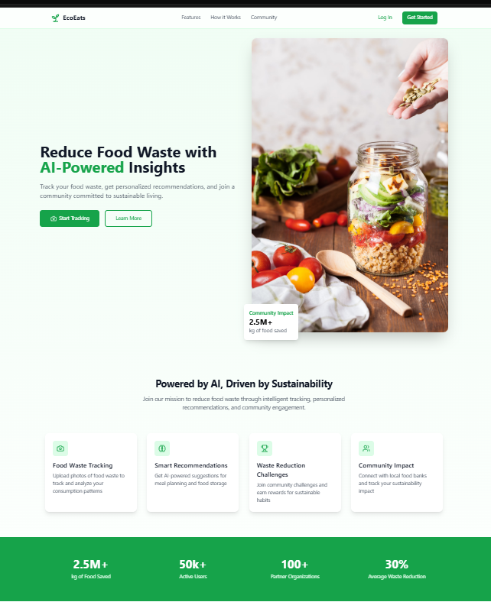

**Start Tracking:**

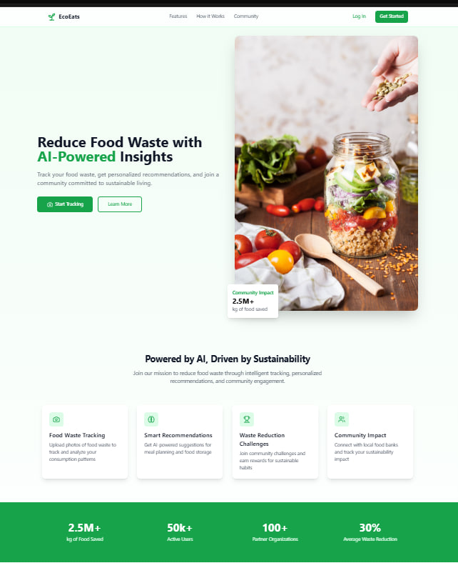Users can scan or upload images of discarded food, and the AI system will recognize the items and analyze the quantity.

For users with eco eats ,the site will track food wastage amount and identify patterns that include over purchasing or excess cooking

**Features Section:** 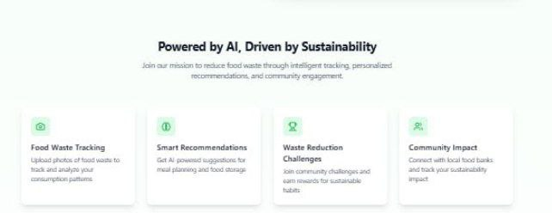

It describes the basic vision of our website i.e;

a) Food Waste Tracking: to reduce food wastage

b) Share Bite: Do Connect donor to various NGOs

c) Waste Reduction Challenges: provide weekly waste reduction challenges

d) Community Impact: Provide a leaderboard for your

**Smart Recommendations**:

It will provide AI-powered suggestions for meal planning and food storage.AI will recommend things that we can de with our waste or unused food i.e; New recipes with leftover food ,Use the common items that are treated as waste from food items i.e; Fruit seeds, Coconut husk.

**Share Bite**

AI will suggest local food banks or NGOs where excess food can be donated. It will track your sustainability impact and provide you a global rank.

**Waste Reduction Challenges**

Join community challenges and earn reward for sustainable habits.It will provide various benefits including discounts from various Reputed Hotels it will benefit hotels too as food wastage will reduce with this step drastically.

**AI TOOLS USED**

1)Bolt to give interacting UI/UX.

2)Chatgpt for other basic features.

3)Blackbox

**KEY HIGHLIGHT**

India's Sustainable Dietary Practices Recognized The World Wide Fund for Nature (WWF) has recognized India's food consumption pattern as the most climate-friendly among G20 nations, according to its latest Living Planet Report. The report highlights that India's diet is the least harmful to the environment, especially when considering the global demand for food production by 2050. If all countries adopted India's consumption patterns, the world would require less than one Earth to sustain food needs, making it a model for sustainability. In contrast, countries like Argentina, Australia, and the United States were identified as having the least sustainable patterns how ai can help in solving the problem